CHAPTER 3
THE GNOSTIC STRUCTURE OF THE ORACLE

Without recognizing the ordinances of Heaven, it is impossible to be a superior man.
Confucius

Throughout recorded history human beings have used oracles to obtain information about how to make correct choices in ambiguous situations. From the Classical Greeks to the Greenland Eskimos, no matter how diverse the culture, each society has always had a recognized method for contacting transcendental sources of information. Under one guise or another, the ego has always known about the Self, and sought its counsel.
Socrates, the man who has epitomized western wisdom and rationality for over two-thousand years, was totally committed to his "daimon" or inner voice. In our conception, he was devoted to the Work, to the will of the Self.
Socrates no doubt believed in "following the argument wherever it led;" but he found that too often it led only to fresh questions, and where it failed him he was prepared to follow other guides. We should not forget that he took both dreams and oracles very seriously, and that he habitually heard and obeyed an inner voice which knew more than he did (if we can believe Xenophon, he called it, quite simply, "the voice of God"). (1)
E. R. Dodds -- The Greeks and the Irrational

In terms of the insights of Analytical Psychology, we recognize here the common identification of the Self with the voice of a deity. Historically, this correlation has been generally consistent. In the following passage from the Old Testament, we see David using an oracle to obtain information about Saul. The answer is unquestionably interpreted as a direct communication with God.
David, however, was aware that Saul was plotting evil against him and said to Abiathar the priest, "Bring the ephod." David said, "Yahweh, God of Israel, your servant has heard that Saul is preparing to come to Keilah and destroy the town because of me. Will Saul come down as your servant has heard? Yahweh, God of Israel, I beg you, let your servant know." Yahweh replied, "He will come down." Then David asked, "Will the townsmen of Keilah hand me and my men over to Saul?" Yahweh replied, "They will hand you over." At this, David made off with his men, about six-hundred in number. (2)
I Samuel 23: 9-13

The ephod was a vestment worn by the high priest, part of which consisted of a breastplate containing the Urim and Thummin which were objects used for divination. What these actually were has been lost to us, but based on the form of the answers here, we can hypothesize that this oracle was probably a fairly simple "yes or no" device.
The Greeks preferred the more detailed utterances of trance mediums, as epitomized by the Delphic Oracles. These were women who had dedicated their lives to Apollo, and lived in his sanctuary at Delphi. On regularly prescribed occasions one of these priestesses would enter a trance and respond to questions put to her by a priest of the temple. The messages received were akin to dream images, and were (like dreams) often highly ambiguous.
One of the most famous of these ambiguous responses was given to king Croesus when he inquired about the advisability of going to war with Persia. The answer was: "If you make war on the Persians, you will destroy a great realm." Croesus interpreted this as a favorable oracle, not realizing that the great realm to be destroyed was his own! (Beware – divination can be very tricky!)
The words of a trance oracle are unfortunately dependent upon the circumstances of the medium's immediate state of awareness, which obviously can vary widely. It is a truism among psychic researchers that the material received from even accomplished mediums often runs the full spectrum from numinous profundity to out-and-out fraud. The I Ching, because it consists of sixty-four hexagrams containing three-hundred and eighty-four separate messages, represents a highly sophisticated frame of reference -- one which allows a little more latitude than a simple "yes or no" answer, yet is still specific enough to confine the wilder speculations inspired by hope and desire.
Which is not to say that you can't misread the Book of Changes: nothing is easier. This is why a casual use of the I Ching often produces inconclusive results. To get full use of the oracle one must study it with the same dedication and seriousness owed to any profound religious or philosophical system. In a later section we will examine some of the finer points of consultation and interpretation, but first a look at the overall structure and history of the oracle is in order.
To consult the I Ching, one asks a question (preferably by writing it down as clearly and concisely as possible), then casts three coins and records their heads/tails configurations according to the following formula;

H-H-T = An undivided, dynamic or yang line... 
T-T-H = A divided, magnetic or yin line............ 
T-T-T = A stressed dynamic line........................ *
H-H-H = A stressed magnetic line..................... *

The results of each throw of the coins are recorded from the bottom upward -- not from the top down -- for six consecutive throws, thus creating a six-lined image, or hexagram. There are sixty-four possible combinations of these.
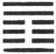
A Hexagram
This image is looked up in the Book of Changes, and any stressed lines are then interpreted in relation to the question asked. Emphatically, the most important elements in any hexagram are those lines which are created by three heads or three tails when throwing the coins -- these are the only lines which are read as pertinent to the query (other than the Judgement, Image and general commentary on the hexagram as a whole). Reading the other, unstressed lines is sometimes useful in determining the rationale behind the symbolism of the stressed lines, but they do not specifically pertain to the matter at hand. If there are no stressed lines, just the Judgement, Image and Commentary of the general hexagram are studied.
This is the modern method of consulting the oracle, but the procedure has evolved considerably over the last five- thousand years. No one knows exactly how or when the oracle came into being, other than that tradition says that it was first committed to writing in 1143 BCE. Prior to that it was apparently an oral tradition passed down from master to apprentice. Although the written version is attributed to King Wen and his son, the Duke of Chou, there is no way of knowing who the original authors were, anymore than we know the true authorship of any ancient document such as the Bible or Bhagavad Gita: and the Book of Changes is far older than either of these.
Some scholars claim that the I Ching is the oldest book in the world. True or not, Chinese tradition says that the semi-mythological King Fu Hsi created the component trigrams which make up each hexagram sometime around 3000 BCE -- if accurate, this would make the I Ching one of the oldest (if not the oldest) known systems of thought. Recorded history began only around 3100 BCE in Mesopotamia with the invention of writing: any era before this is considered "pre-historic."
It is said that Fu Hsi received the images of the trigrams (which will be discussed in more detail later) from patterns on the back of a tortoise which emerged upon a riverbank where he was meditating. This seems to have determined the form that Chinese divination was to take for the next two-thousand years, for "Plastromancy," which is divination by tortoise shells, was the preferred method of consulting the oracle at least until the time of King Wen. The technique involved writing a question upon the plastron (the flat, segmented underside of a tortoise), which was then manipulated with a red-hot poker until it cracked. The pattern of cracks determined the message, which was then interpreted by a shaman trained in the tradition. Interestingly enough, this was usually the Emperor, a king, or some other ruling official. Plato's ideal of the Philosopher King was apparently often a reality in ancient China.
About the time that the I Ching was written down, the use of yarrow stalks for divination came into favor. This is a mildly complicated and time-consuming procedure involving the manipulation of fifty stalks of the Milfoil plant. The method is still used today, and some opinions maintain that it is the only legitimate method for consulting the Book of Changes. Whatever merits are claimed for this technique, ancient tradition cannot be one of them, for the coin oracle is almost as old, and plastromancy antedates them both.
Within a century of the death of Confucius, during the "Warring States" period of Chinese history (403 to 221 BCE), the coin oracle was invented. This was undoubtedly due to the exigencies of the time -- wars and battles were more or less continuous during that era, and a commander in the field didn't have time to go through a lengthy manipulation of yarrow stalks to divine his immediate strategy. Well into modern times the questions of warfare have been considered legitimate subjects for the oracle. It has even been implied that one of the reasons that Japan lost World War II was because Her high command no longer consulted the I Ching for tactical decision-making.
World history in the Twentieth Century may also be perceived as a "Warring States" period: modern life is unfortunately too fast-paced to allow the leisure of prolonged meditation, so the coin oracle is the usual method of divination for most contemporary users of the Book of Changes.
Structurally, each hexagram is made up of a lower and an upper three-lined figure, or "trigram." There are eight possible trigrams, and each one has a long list of symbolic attributes associated with it.

Upper Trigram

Lower Trigram

As previously noted, each of the three lines comprising a trigram is either divided or undivided, the divided lines being magnetic, or female, and the undivided lines dynamic, or male. This male-female polarity within the lines of the hexagram is a symbolic depiction of the prevailing relationships between the "pairs of opposites" now operating in the situation under question. As moderns we usually think of polarity in scientific or technological metaphors -- as the positive and negative poles of an electrical circuit, for example. In pre-technological times, and in the symbols of the unconscious psyche, polarity has traditionally been symbolized by the relationship between male and female.
This is an extremely important point, and one which is easily misunderstood. We must not forget that we are dealing with symbolic, not literal, images. Male-female polarity is usually experienced as sexuality. Because this is one of the most powerful forces operating within the psyche, it is always very easy to misinterpret such images. Dream symbols are often highly sexual in nature, but those who study them with care find that "sexy" dreams frequently refer to polarized dynamics within the unconscious, and not to sexuality per se. Conversely, dreams that are concerned with sex often have no overt sexual content at all.
The I Ching is a psycho-spiritual system which gives symbolic images of the polarities inherent in any given situation. One of the most important keys to understanding the Book of Changes is to be able to see the symbolic attributes of maleness and femaleness as emblematic of polarized forces which transcend physical sexuality.
It will be remembered from Chapter I that the gnostic conception of the creation of the multiverse involved the emanation of paired male and female powers ("syzygies") from a Cosmic Unity. The I Ching reflects this idea in the structure and relationship of its polarized lines. The description of the original Oneness and the series of emanations which proceeded from it is found in Chapter XI of the Great Treatise -- one of the Confucian appendices to the Book of Changes:
Therefore in the system of the (I Ching) there is the Grand Terminus, which produced the two elementary forms. Those two Forms produced the Four emblematic Symbols, which again produced the eight Trigrams. (3) -- Legge translation.

Unless one understands what is meant by "Grand Terminus," the passage is not particularly lucid. Wilhelm translates this as: "Great Primal Beginning," and in his commentary gives us the original Chinese term: Tai Chi.
The Tai Chi symbol, of course, is now familiar worldwide as a circle of unity containing two polarized interacting opposites. Of Taoist origin, it has grown beyond its roots to become a primary symbol of Eastern thought which is even found on the flag of the Republic of Korea. Tai Chi has also been translated as the "Supreme Ultimate," and that is the phrase we will use here.
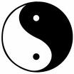
Tai Chi, or Supreme Ultimate

Grand Terminus, Great Primal Beginning and Supreme Ultimate are all descriptions of the state of cosmic unity which preceded the creation of the "two elementary Forms." These, of course, are the dynamic and magnetic male/female, yang/yin) principles -- the so-called "pair of opposites" represented in the I Ching as solid and divided lines. From their "sexual intercourse" (remember that psychic symbolism is usually couched in sexual metaphors when it refers to polarity), is produced the multiverse.
The Kabbalah, arguably the most systematic synthesis of gnostic thought known to us, describes creation by an almost identical concept in which a male and a female principle emanate from an androgynous unity. The kabbalistic diagram for this is called the "Supernal Triad."
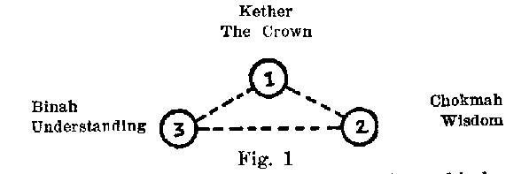
The Supernal Triad

If we superimpose the Tai Chi symbol upon the sphere at the apex of the Supernal Triad we see that the two concepts are identical. The Supernal Triad of the Kabbalah is just an "exploded view" of the Taoist Supreme Ultimate. The Supreme Ultimate shows the original Unity with the polarized multiverse latent within it; the Supernal Triad shows the emanation of the multiverse out of that primordial Oneness. The Tao Te Ching, the “bible” of Taoism, describes this primal emanation in language which clearly evokes an image of the kabbalistic Supernal Triad:
Out of Tao, One is born;
Out of One, Two;
Out of Two, Three;
Out of Three, the created universe.

Thus we see that there is nothing at all contradictory in the two schemes. And such ideas are no longer just the special province of metaphysics and mystical philosophy, for in the field of quantum physics, the cutting edge of scientific investigation, analogous hypotheses are being entertained:
Can we conceive of physical objects, or even the entire universe, coming into existence out of nothing? One place where such a bold possibility is taken seriously is on the east coast of the United States where there is a curious concentration of theoretical physicists and cosmologists who have been manipulating mathematics in an attempt to divine the truth about creation ex nihilo ... All of them believe that in one sense or another "nothing is unstable" and that the physical universe blossomed forth spontaneously out of nothing driven by the laws of physics. (4)
P. Davies – Superforce

Logically, semantically, the idea of something emanating from nothing is a non-sequitur. The word "no-thing" is an abstraction which only has meaning in reference to "some-thing." As an absolute reality, it is a meaningless concept, for as long as even one particle exists, "no-thing" cannot exist except relatively. To perceive that subatomic particles sometimes seem to emanate from "nothing" is to be handicapped by a language (and all of the conceptions we create from it) which is an artifact of the restrictions of spacetime. The nothing from which the particles are seen to emanate (and from which the multiverse emanated) is the latent Pleroma of the gnostics. If the laws of physics which drive the creation of particles from nothing in the above quotation could be reduced to but one simple principle, it would be that of the interaction ("intercourse") between the pair of opposites -- without the principle of polarity nothing as we understand it in spacetime could exist. This is the principle which animates the I Ching.
Usually (but not always -- there are some exceptions which prove the rule), the meaning of each line in a hexagram is derived from its polarity in relation to its position in the figure and to the polarity of its "correlate line." The correlate line is the line which mirrors any given line's position in either the lower or the upper trigram. For example, the first line in the hexagram (which of course is also the first line in the lower trigram) has its correlate in the fourth line of the hexagram because that is the first line of the upper trigram. Therefore, lines one and four, two and five, and three and six are all correlates.
----- 4

----- 1
Correlate lines

In the above example (Hexagram #59, Dispersion), the first and fourth lines are both magnetic and the second and fifth lines are both dynamic. Note that only the third and sixth lines are polarized magnetic and dynamic lines. Generally, to be "correct," each line should be both in its proper place and opposite in gender from its correlate line. In terms of polarity, positive should always balance with negative, dynamic with magnetic. In sexual terms, male and female should be properly "married" to each other -- a syzygy or Tai Chi image of balanced forces. The symbol of marriage is both universal and profound in all mystical systems -- it is a powerful archetype within the unconscious psyche, and we shall have much occasion to refer to it throughout this book.
The upper trigram in each hexagram is in the place of "Heaven," and the lower trigram is in the place of "Earth." In gnostic psychological terms we know that Heaven is a projection of the inner dimensions -- the Pleroma; therefore, by extension, Earth must refer to the material spacetime dimension. Thus in the structure of each hexagram we see an image of what the alchemists called the unus mundus, or "One World," which is nothing other than the inner dimensions reflected in the external multiverse, and vice-versa. The Hermetic Axiom: "As above, so below" simply means that all dimensions are mirrored in each other. The idea of a proper correlation between Heaven and Earth then, is an extremely important concept -- it implies an ego and Self in harmonious accord.
To be in harmonious accord is to reflect an archetypal gestalt of perfection -- a state in which each syzygy in the multiverse is mated to its original and proper correlate. This archetype is symbolized in the I Ching by reference to the "Ancestral Temple" -- the perfection of the Work as it exists beyond spacetime in a realm where time is meaningless: where "ancestral" means future as well as past. This is the New Jerusalem, the Perfected Work, the Philosopher's Stone, the attainment of Unity.
An analogous correlation of three "lower" forces with three "upper" can be found in the book of Genesis, where it is stated that God created the world in six days. The scheme is provocatively similar to the concept of correlate lines in the hexagrams of the I Ching. Synchronicities such as these are always a clue that archetypal themes are involved:
Some early rabbinic commentators observe that the main elements were created in the first three days; and embellished in the second three; and that a close symmetry can be discerned between the first and fourth days, the second and fifth, the third and sixth.

First Day Fourth Day
Creation of the heavens, Creation of the luminaries --
its separation from sun, moon and stars --
darkness. to separate day from night and season from season.
Second Day Fifth Day
Creation of the heavens Creation of birds that
and separation of the fly through the heavens,
upper waters from the and of fish that swim
lower. through the lower waters.
Third Day Sixth Day
Creation of dry land and Creation of beasts, men
establishment of its and creeping things that
immobile woods and herbs. walk on dry land. (5)

Graves and Patai -- Hebrew Myths

In the scheme of Genesis, God created the world in six days, saw that what He created was good, and rested on the seventh day. This sevenfold perfection of the Work (the Ancestral Temple) could be described in I Ching terms as each line in a hexagram symbolizing a day, and the whole hexagram its septenary completion. This archetype of Completion is found in the hexagram of that name, and is the standard of reference which determines the proper placement of any given line in any given hexagram.
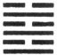
Hexagram Number Sixty-Three – Completion

This hexagram depicts all of the lines mated with their proper correlates. Line one, dynamic, is married to his destined mate in line four; line two is united with her spouse in line five, and lines three and six are also correctly matched. In addition, each line is in its proper place -- the hexagram begins with a dynamic line and alternates in polarity through all six positions. The fifth line, which is almost always the place of the "ruler," is properly dynamic (as befits a sovereign), and the fourth line, which is the place of the "minister" is properly magnetic (as befits the servant of a king). We see in the overall symbolism some hints about the archetypal meaning of the syzygy -- the properly mated pair -- as well as about the correct relationship between the Self and its satellites.
The name of the sixty-third hexagram in all translations denotes the idea of accomplishment or completion -- the Work in its ideal or finished state. Thus the correct positions of the lines in the hexagram of Completion are an archetypal template by which the lines of all the other hexagrams are measured. This is a fundamental structural component of the I Ching, and absolutely essential to a full comprehension of its meaning.
In addition to the gender polarity and position of the lines, the meaning of a hexagram is also determined by the characteristics of its component trigrams. Each of these has an almost endless list of symbolic attributions. The easiest scheme to remember while first learning the trigrams is the universal archetype of the "family."
First, there are the two trigrams symbolizing the father and mother -- the primordial pair of opposites which have through their coupling emanated the forces symbolized by the other trigrams: their three male and three female children. These are the eldest son and eldest daughter, who are followed by the trigrams of the middle son and middle daughter and finally the youngest son and youngest daughter. Each member of this family has his or her own unique "personality" of symbolic attributes which influence the meaning of any hexagram in which they appear.
Father Mother

Eldest Son Eldest Daughter

Middle Son Middle Daughter

Youngest Son Youngest Daughter

Note that the polarity of the lines in each pair of trigrams is exactly reversed. They are syzygies: perfectly matched powers which have emerged from the Supreme Ultimate via the primal pair of opposites. In these images we see yet another rendition of the basic gnostic conception of the creation of the multiverse.
In the relationships between the four dynamic trigrams and the four magnetic trigrams is found the same male-female polarity which is inherent in the lines themselves. Not only does each line have an inner tension in relation to its place and correlate, but the trigrams are also polarized as larger units within the figure. Seen in this way, a cast hexagram becomes a kind of evoked gestalt of polarized forces undergoing continuous change, caught during one instant in time.
The I Ching is a profound psycho-spiritual system -- one can live a full and moral life according to its principles without reservation. It was intended to be used for this purpose, and a frivolous "Ouija board," or party game attitude is alien to its spirit. The book demands much from a student, and traditionally one of the first lessons to be mastered is the memorization of the trigrams and their basic attributes -- followed by the memorization of the hexagrams by name and number. It is my understanding that the original Chinese version of the I Ching had no identification table in the back of the book with which to locate the hexagrams: the student was expected to commit these to memory. This is not difficult, and one learns a great deal in the process.
A good way to begin is to study those eight hexagrams which are composed of identical trigrams:
1. -- The Dynamic
2. -- The Magnetic
51. -- Shock
57. -- Penetration
29. -- Danger
30. -- Clarity
52. -- Keeping Still
58. – Joy
The Judgments, Images and initial commentaries for these eight hexagrams provide an excellent introduction to the attributes of their component trigrams. It is the relationship between the trigrams which usually determines a hexagram's symbolic gestalt; the polarity of the lines within each hexagram is a more abstract elaboration of this initial relationship. Therefore it is first essential to learn the personalities of the trigrams.
The structure of the trigrams determines yet another dimension of meaning within each hexagram. A trigram may be described as a central line sandwiched between the line above and the line below it. This is the "central place" mentioned so often in the commentaries. The central places within each hexagram are the second and fifth lines -- which are also correlates. As noted, the fifth line is usually the place of the "ruler" of the hexagram. This is the throne of the king who rules all of the other lines as subjects. The second line in general, and the fifth line in particular, are stressed positions. Being central, they symbolize the "middle way" or "golden mean." They are the fulcrums or balance points of every trigram, and represent that place where dynamic and magnetic forces are in harmony with each other.
This general idea is found in other symbol systems in the concept of the dialectic -- thesis and antithesis are in opposition until they are resolved in synthesis. The image of this is usually portrayed as some version of a triangle. We have already seen this in the Supernal Triad of the Kabbalah. Here the androgynous Supreme Ultimate (Tai Chi) divides to become the primordial male and female polarity of thesis and antithesis; yet we can see in the diagram that each one of these opposites may find its synthesis in the union from which it emanated. The dialectical process can move in either direction: "upward" toward synthesis, or "downward" toward differentiation. This is how the multiverse was created out of Unity. The Work is an example of an extreme synthesizing process; schizophrenia is an example of an extreme differentiating process.

Androgyne: Synthesis
Female: Antithesis Male: Thesis

The Supernal Triad as a Dialectic

In I Ching terms, the ideas suggested by the polarity within these images point toward the "middle way" or central place within the trigrams which make up each hexagram: Polarity is resolved in union; polarity is resolved in synthesis; polarity is resolved in the middle.
It is important to note that the middle way, the path of the mean, does not symbolize mediocrity, compromise or conformity to majority opinion, as is commonly implied by "middle class" or bourgeois morality. The middle way is a conscious recognition and acceptance of the whole spectrum of awareness and a conscious balancing of the polarities of either extreme. Bourgeois morality fears and repudiates extremes; the middle way accepts them and integrates their force into a harmonious whole. While bourgeois morality represents the compart-mentalization and repression of consciousness, the middle way is the means toward attaining its full realization.
Two trigrams make up one hexagram. A hexagram is technically any figure containing six elements. If you look the word up, you will discover that the Star of David of Judaism (also called: Solomon's Seal or the Shield of David), is also a hexagram:
The Magen David ("Shield of David"), is a hexagram or six-pointed star formed by two equilateral triangles which have the same center and are placed in opposite directions. From as early as the Bronze Age it was used -- possibly as an ornament and possibly as a magical sign -- in many civilizations and in regions as far apart as Mesopotamia and Britain... It began to figure as a magical sign from the early Middle Ages. (6)
G. Scholem – Kabbalah

It is not generally known that long before it became the emblem of Judaism in the 17th and 18th centuries, this was an esoteric symbol portraying the interpenetration of Heaven and Earth -- exactly the significance contained in the upper and lower trigrams of an I Ching hexagram. For our purposes here, in the symbolic sense, "triad" and "trigram" have identical meanings.
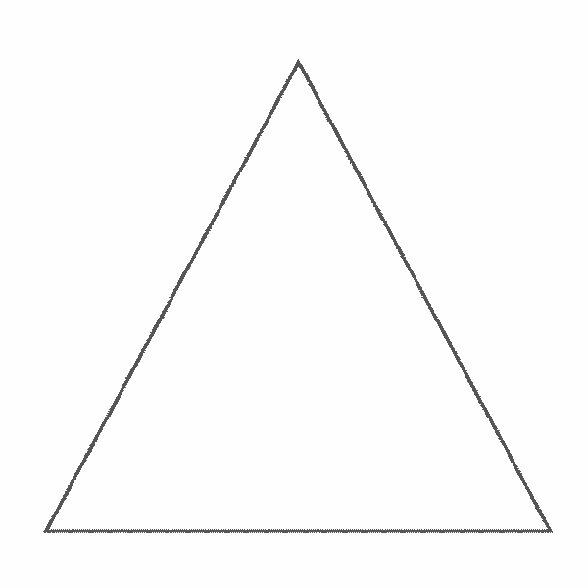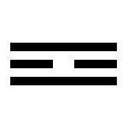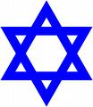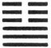
Star of David Hex #11, Harmony
A Triad A Trigram Two Hexagrams

The hexagram in the Book of Changes which most closely approximates the balanced symbolism of the Star of David is number eleven -- Harmony. In it we see (in Legge's translation of the Confucian commentary): "The union of Heaven and Earth, and all things consequently united -- high and low, superior and inferior are all in accord." The McClatchie translation states it less primly: "Heaven and Earth have now conjugal intercourse with each other, and the upper and lower classes unite together."
Once again we see how the deep psyche (the Pleroma) uses sexual metaphors to describe the basic polarities which animate spacetime. Dynamic and magnetic forces are polarized until they unite "sexually." This, in its ideal state, creates a synthesis, which in the Western Mystery Tradition is often portrayed as the so-called Hermetic Androgyne: a half-man, half-woman. The same idea is symbolized in Hindu- Buddhist iconography by the image of the primal syzygy: The god Shiva in sexual union with his correlate, the goddess Shakti.
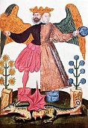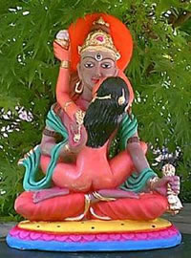
The Hermetic Androgyne Shiva and Shakti

In the author's opinion, neither portrayal is as satisfactory as the Tai Chi symbol -- the image of the Supreme Ultimate which is holographically mirrored in each of its myriad manifestations. No matter how far we may stray from Unity, we cannot escape it, for ultimately we are all portions of one reality: we really are all One at the highest level of awareness.

Within the magnetic is the principle of the dynamic, and within the dynamic is the principle of the magnetic. Within the female is the seed of the male, and within the male is the seed of the female. In Jungian parlence, every man has an "anima," or female component within his psyche, and every woman has an "animus," or male component within hers. Each principle contains its opposite.
To understand how sexual polarity can symbolize non-sexual situations, particularly in questions which relate to the inner dynamics of the psyche, we must refer to another ancient metaphor of consciousness which has been modernized in Jung's conception of the "Four Functions."
Awareness may be differentiated into four distinct components: First and most immediately, we have our physical senses which tell us that we are alive -- these constitute the foundation of consciousness within the body that Jung called Sensation. Hot, cold, bright, dim, loud, soft, bitter, sweet, etc. are all differentiations of the pairs of opposites presented to our senses. Senses are specialized receptors for the comprehension of spacetime conditions, and sensations are therefore the "lowest" common denominator of human consciousness. The ancients symbolized this function with the element of Earth. To be "earthy" is to be sense- oriented. The Tarot equivalent is the suit of Pentacles.
Jung's second function of consciousness is that of Emotion or feeling. Love, hate, fear, anger, lust, etc. are all closely allied with the Sensation function in that they usually represent reactions to sense stimuli to one degree or another. Nevertheless, emotions are qualitatively more "abstract" and complex than our relatively "simple" sense impressions, and so they are symbolized by Water in the ancient classification. Emotions are to sensations as water is to earth. Emotions often "well up" in us like a tide of water. The Tarot attribution is the suit of Cups.
Third, is the Thinking function which our era places such a high value upon. This is the ability to differentiate and organize our perception and to make value judgements based upon it. For example, the Sensation of being burned by a hot stove may evoke the Emotion of anger. A primitive, unevolved consciousness might respond by striking the stove, but a psyche in which the Thinking function has evolved would be more likely to put some ointment on the burn and resolve to be more cautious around stoves in the future. Thought is more "abstract" and complex than emotion, so the ancients assigned it the symbol of Air. As air is to water, so is thought to emotion. The Tarot classification is the suit of Swords. (As the sword cuts, so does thought differentiate.)
Finally, there is Intuition -- the most subtle kind of awareness. It is also the highest, because it transcends all other ways of knowing and brings us information from deep within the core of the psyche. The cliche example of intuition is the story of the individual who cancels an airplane trip on the basis of an "illogical hunch," which is confirmed when the plane crashes a short time later. This is just a highly dramatic portrayal of a state of consciousness which is actually always available to us -- if only we knew how to contact it. The ancient symbol of intuition is fire. As fire is more "abstract" and of a completely different category than air, so is intuition in relation to thought. The Tarot attribution is the suit of Wands.
Consciousness has evolved over eons and is still evolving. Humankind has passed through the Sensation and Emotion stages and is now generally focused in the Thinking phase of development. The technological and scientific discoveries of the last five-hundred years could only have emerged from awareness which was able to differentiate and synthesize. The Intuitional phase of development is the next great step forward for our species, but as yet there are relatively few people who have begun to develop it. The attainment of our full intuitional powers is the goal of the Work, and the Book of Changes is nothing if not a device by which one develops intuition.
When we assign the four ancient components of consciousness to either Heaven or Earth, we quickly see that Earth and Water belong to Earth, and Air and Fire belong to Heaven -- the primordial fire of the Heavenly sun being the parent of any earthly fire. The sexual attributions of these elements also fall right into line -- the Thinking function (Air) is associated with Logos, a masculine attribute, and Sensation (Earth) and Emotion (Water) are considered portions of Eros, the feminine sphere. The Intuition function, because it transcends all of the others can be considered androgynous -- it is the consciousness of the Self, which exists beyond the polarities of gender.
It is the thesis of this book that the Logos (Thinking function) is the key to the conscious evolution of the psyche. This is a tricky distinction which is too easily misunderstood. When the intellect differentiates and chooses and conscious intention rules, the Work can proceed. When the emotions, desires and appetites rule, the Work loses focus and growth is random and inconclusive. Therefore we see in the masculine and feminine attributes of Logos and Eros a symbolic hierarchy of value which a superficial understanding might easily misinterpret as some version of "male chauvinism." Not so! It is essential to remember that every psyche, male and female, has these same four functions operating within it: we are spiritual androgynes temporarily inhabiting sexually polarized bodies. For a woman to take offense at an oracle which tells her to control her emotions with her reason because these are symbolized in sexual metaphors is to refuse to acknowledge a basic truth of the unconscious psyche -- that our spontaneous inner images choose to express themselves in this way whether we like it or not. Since the highest forms of awareness are androgynous and intuitional, the sooner we can overcome our cultural conditioning on this matter, the better off we'll be. Indeed, the Work cannot proceed until we do so. For male chauvinists who may feel smug at these ideas, it must be emphasized that the ego is always "female" or magnetic in relation to the dynamic Self. In that sense we are all female.
The male force is that which acts upon the world, while the female force is that which allows the world to be receptive to God's power. This is the reason that we refer to God in the male gender when we pray. Of course, although we usually refer to God as a male, in His true essence He is without gender. We refer to Him as a male, however, because we want Him to act upon the world through the male force of providence. We then leave ourselves open to God's providence as a female is open to her mate. (7)
A. Kaplan -- Jewish Meditation

If we substitute the word "Self" for the word "God" in the above quotation we can see it as a paraphrase of our concept of the Work.
As we saw in the preceding chapter, Jung associated the archetypal complexes with the instincts. Therefore we can generally assign them to the categories of Sensation and Emotion. The ego is ideally the choicemaker of the psyche, and to it belongs the Thinking function. The Self, of course, is the source of all Intuition. In an unregulated psyche, the complexes gratify their desires through the senses and emotions, and the intellect generally serves to rationalize this behavior. The Self is relatively isolated under such circumstances.
In a highly evolved psyche, the ego consciously regulates the emotions and instincts according to the will of the Self. In terms of polarity, the ego is magnetic to the Self, but dynamic to all the other complexes. While the I Ching is probably the most sophisticated tool ever devised for consciously furthering the Work, the ego will soon realize that the Self which emanates from the oracle is not yet a unity: in gnostic terms, we are serving a high-level archon which is itself striving for union with the Supreme Ultimate.
In the Sensation, Emotional, Thinking and Intuitive modes of awareness as described by Jung, we see the same hierarchy which was conceived by the kabbalists as a series of "worlds": at the bottom is our physical world of Sensation which we call spacetime; next comes an Emotional realm which exists as a completely separate dimension, but which we actually experience as autonomous feelings. This is the so-called "astral plane" of occultism. Above these are two more dimensions of increasing abstraction from which we receive Mental and Intuitional impulses. Because they are clearly not "Earth" all of these realms have been conceived of as "Heaven."
The Book of Changes makes a great deal out of this distinction between Heaven and Earth, and the polarity which defines them: Heaven always being dynamic, yang or masculine, and Earth magnetic, yin or feminine. These are universal attributions -- no culture I know of thinks in terms of "Mother Sky" or "Father Earth." In Appendix VI of the I Ching, entitled: The Orderly Sequence of the Hexagrams, is described the initial intercourse between Heaven and Earth:
Following the existence of Heaven and Earth, there is the production of all things. The space between Heaven and Earth is full of all these things. Hence [the hexagram] Ch'ien [Heaven] and [the hexagram] K'un [Earth] are followed by the hexagram Tun, which means fullness. (8)
Fung Yu-Lan -- A Short History of Chinese Philosophy

Legge and Wilhelm translate "fullness" as "filling up," but this in no way alters the meaning here: this is the fullness of pregnancy -- the great sea-soup of incipient being, where everything has its beginning and ending. We emanate from this fullness -- all our thoughts, emotions, intuitions, indeed our very body, soul and spirit are formed by its templates. To act in spacetime is to give birth to something originating from the "fullness" of the psyche. To choose is to modify these forces; not to choose is to be modified by them. Of course the reader is by now aware that this fullness mentioned in the I Ching is identical with the gnostic conception of the Pleroma:
Pleroma: Gk -- that which fills, to make full. 1. Plenitude... b. The fullness of being of the divine life held in gnosticism to comprise the aeons as well as the uncreated monad or dyad from which they proceeded.
Webster's Third New International Dictionary

We see in this definition that the Pleroma conceptually includes both the inner multiverse and the unity from which it emanated -- "Heaven" is every dimension through which our awareness unfolds before it is grounded ("earthed") in a physical spacetime body. What we call life is a continuous pressure from the Pleroma -- a current of energy originating in "Heaven" and terminating in "Earth." Life, the life- force, that which human beings experience as consciousness, is precisely an emanation. Dreams are emanations; thoughts, emotions, intuitions and the longing of the senses for their objects are also emanations. To "die" is to have this energy re-polarized away from spacetime to another terminal (another dimension or world) in the Pleroma. The energy itself never ceases, it just changes its terminal of focus.
The two poles of this cosmic polarity of Heaven and Earth are often portrayed as geometrical shapes -- Heaven as a circle, and Earth as a square. The idea is found in the emblem of Freemasonry -- in the center of a compass superimposed upon a square (reminiscent of the Star of David) is the letter "G", which stands for God. (Older versions of the symbol substitute this letter with the image of an all-seeing eye.) The idea is that of the interpenetration of the Pleroma and spacetime dimensions (Heaven and Earth) in one unified whole -- this is the unus mundus (one world) of alchemy. God, Unity, the Supreme Ultimate from which all this emanated, is in the center. One could substitute the Tai Chi symbol for the letter "G" and be conceptually identical in meaning.
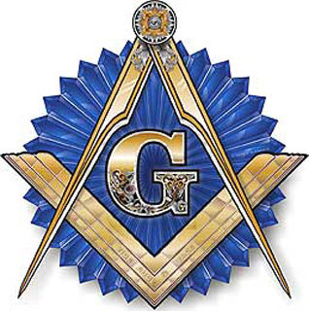
Masonic Symbol

Shao Yung (1011-1077 CE), a noted Neo-Confucian philosopher, is known for his round and square chart of the hexagrams which portray a square Earth within the circle of Heaven. Implicit is the idea of spacetime unfolding from within a greater dimension. It is significant to note that old Chinese coins are also round with a square hole in the center, and that a coin (the object by which an oracle is cast) is itself a Tai Chi symbol: it is one, yet has a heads and a tails side. If heads is feminine, and tails is masculine, the whole coin is androgynous: the side you see hides the side you don't see; animus is hidden in woman, and anima is hidden in man.
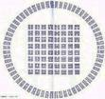
Shao Yung's Round and Square Chart of the Hexagrams
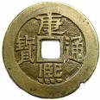
Ancient Chinese Coin
Each trigram in Shao Yung's chart represents a force in the multiverse. Each hexagram is a combination of the forces of two trigrams, and in their arrangement and sequence within the chart, in their union and interaction, combination and re-combination, are created all possible nuances of experience. The "energy field" generated by Shao Yung's chart is analogous to that symbolized by the kabbalistic Cube of Space, and the Tarot arcanum, the Universe (or World) card placed at its center symbolizes Huai-Nan Tzu's observation:
Indeed, one cannot put a compass to the roundness of heaven, and one cannot put a carpenter's square to the square of the earth. From antiquity to the present, we call that "time;" the four quarters, up and down, we call that "space." The Way lies in their midst, but no one knows its place of origin. (9)
Huai-Nan Tzu -- Taoist, 2nd Century BCE
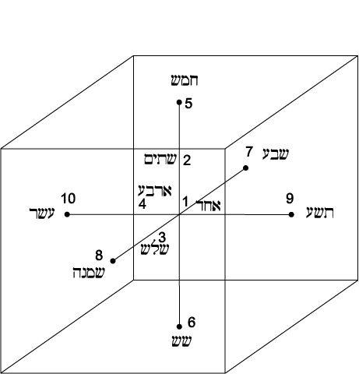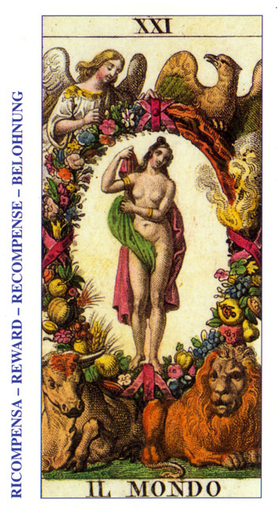
Cube of Space Tarot Universe or World

While plastromancy may seem to modern consciousness as a rather far-fetched means of divination, it makes sense when understood in relation to the symbolism of the tortoise in China, where the “circular” carapace above represents Heaven, and the “square” plastron below symbolizes Earth. Seen in this way, the modern coin oracle, because of the shape of old Chinese coins, actually becomes an analogue of the ancient tortoise shell oracle.
Whether we are able to recognize them or not, archetypes are continuously emanating into our spacetime awareness in delightfully creative ways. In these symbolic images are keys to a wider comprehension of the recurrent universal problems of life in a spacetime dimension. The reader should by now have sufficient information to be able to tackle a famous old alchemical diagram:
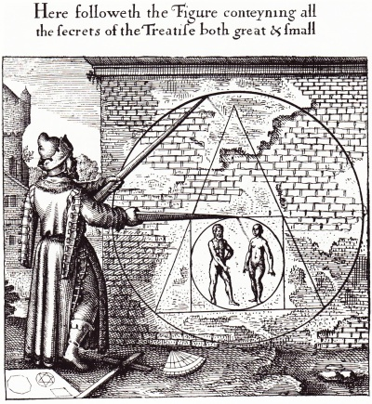
In this necessarily brief introduction we have examined only a few of the many symbolic correspondences between the images found in the I Ching and those of other traditions. There are many more, but the point has hopefully been made that the Inner Truth which informs our choices for the proper regulation of the Work emanates from the Self via the structure of the oracle. The Book of Changes is itself a powerful template for the modification and evolution of consciousness. As our comprehension matures, so does our behavior. This process continues until the actual physical use of the oracle becomes superfluous: this is the completion of the first phase of the Great Work.

FOOTNOTES

1. E. R. Dodds -- The Greeks and the Irrational, University
of California Press, Berkeley, 1951, Pg. 184
2. A. Jones, ed., The Jerusalem Bible, Doubleday, Garden City, NY, 1968, Pg. 320
3. J. Legge, The I Ching, Dover, NY, 1963, Pg. 373
4. P. Davies -- Superforce, Simon and Shuster, NY, 1985, Pg. 199
5. Graves, R. & Patai, R. -- Hebrew Myths, Greenwich House, New York, 1983, Pg. 24
6. G. Scholem -- Kabbalah, New American Library, NY, 1978, Pg. 362
7. A. Kaplan -- Jewish Meditation, Schocken Books, NY, 1985, Pg. 154
8. Fung Yu-Lan -- A Short History of Chinese Philosophy, Free Press/Macmillan, NY, 1966, Pg. 171
9. Huai-nan Tzu -- quoted in W. Baskin, ed. -- Classics in Chinese Philosophy, Philosophical Library, NY, 1972, Pg. 255

